**Candidate Engagement**

* **Created New Job Order .NET Developer**
* **Copy Job Order From another job Order Name As .NET Developer Hiring1**

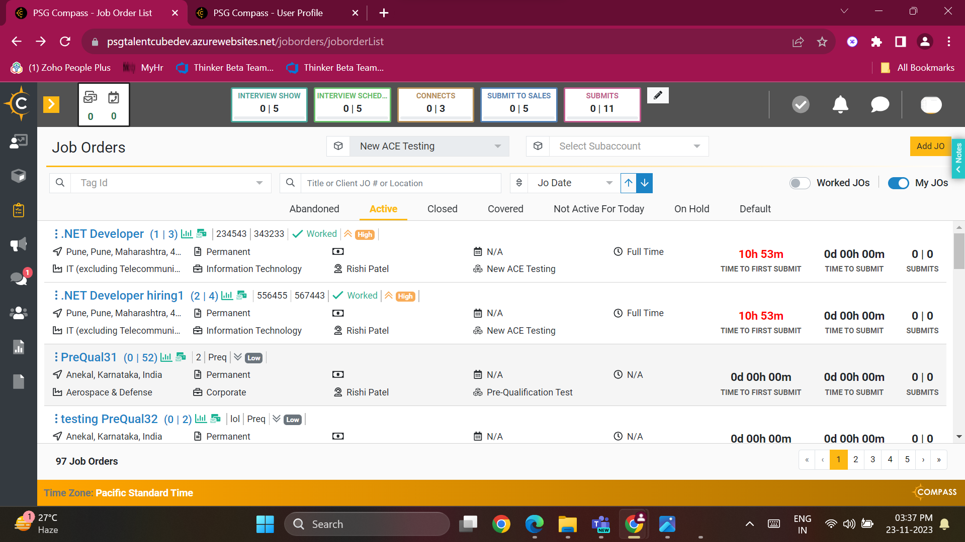

* **Added New Candidate in Job Order**

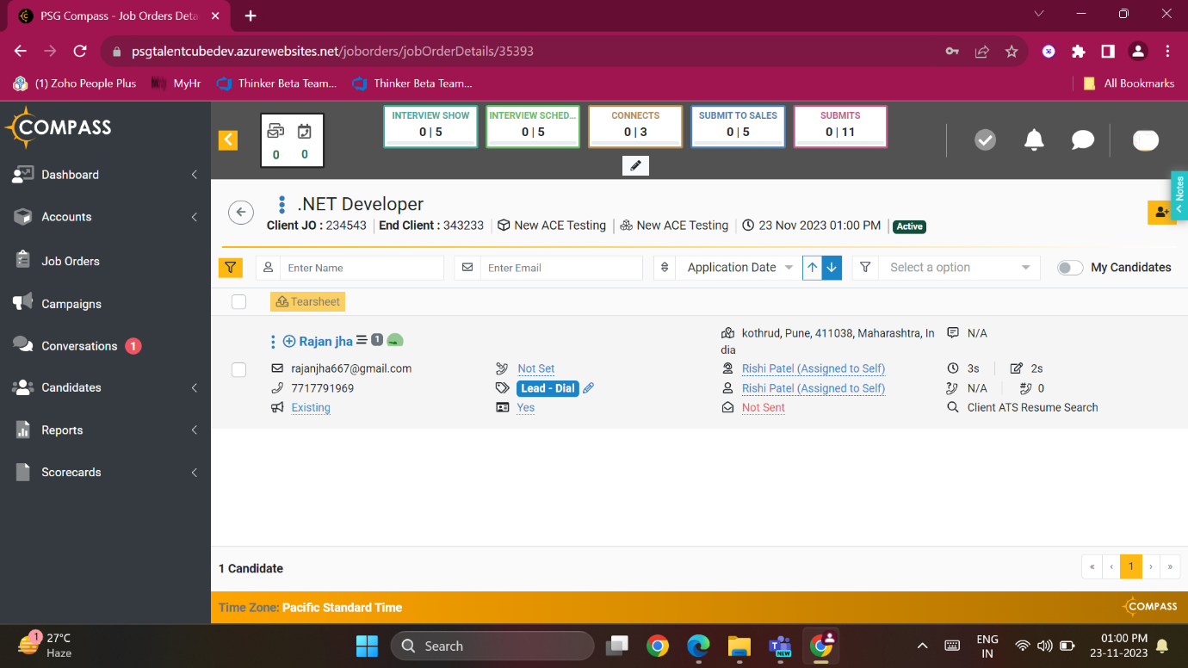

* **After adding the candidate, it is added to the engagement queue and email, SMS, and WhatsApp**

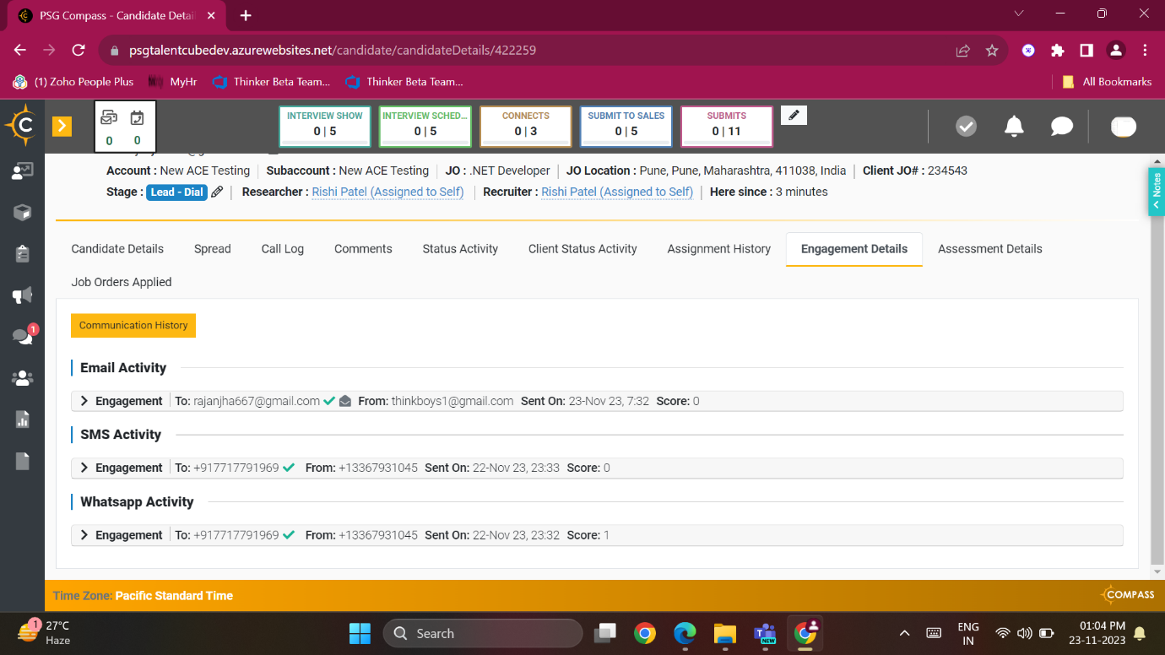

* **After clicking on Unsubscribe Through email in the portal it shows an unsubscribe Icon on the Candidate profile**
* **But when the candidate replies STOP through SMS it does not show Unsubscribe Icon**
* 
* **It is also not showing the candidate's reply in the SMS/WhatsApp Communication history or chat window**

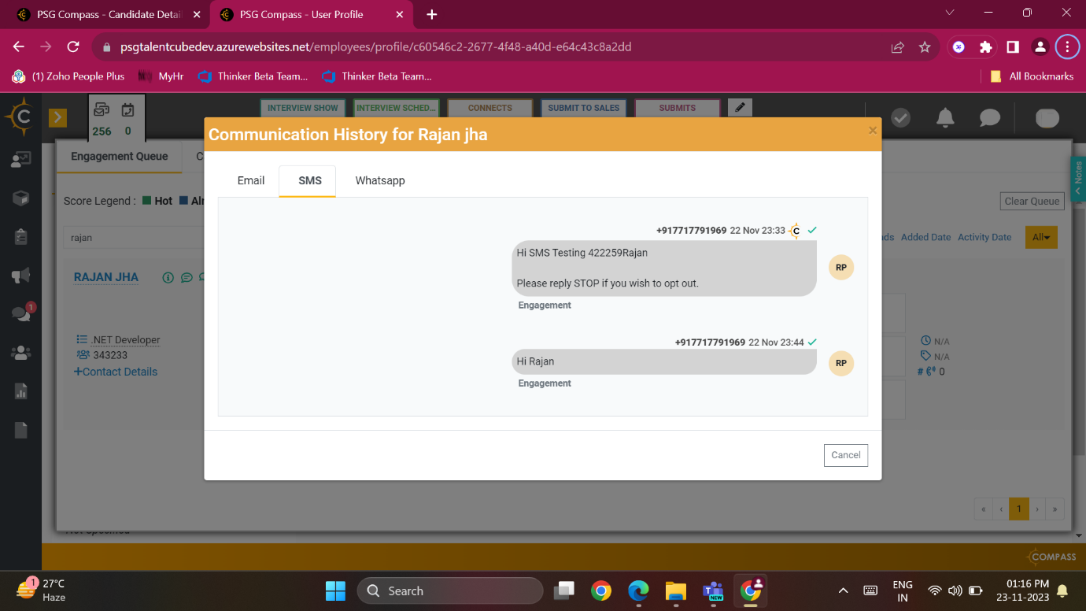

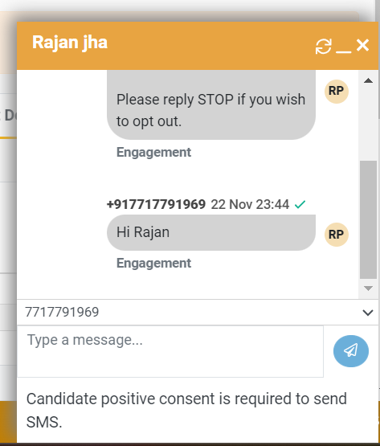

* **Also Edit the Engagement Template At job order level**
* **Added the action button in the template and send it to the candidate and check the response**

